**Student Information**

* **Student Name:** Ayesha Ndlovu
* **Student Number:** 10474774
* **Course:** WEDE5020
* **Institution:** The Independent Institute of Education
* **Date:** 27 September 2025

# Formative-Part-2

# SPCA Cape of Good Hope Website

## **Overview**

## This website showcases the SPCA Cape of Good Hope, providing information on adoption, donations, education, services, and contact. It is fully responsive for desktop, tablet, and mobile devices, and uses a consistent color palette of **Dark Blue, Orange, and White** for a professional yet friendly look.

## **Goals for the website**

## Raise awareness about the SPCA’s mission and values. Educate the public on responsible pet ownership and animal welfare. Showcase adoptable pets and make the adoption process simple. Promote adoption over buying pets from breeders or shops. Encourage community involvement through volunteering and fostering. Provide an enquiries page for questions and event information. Support fundraising with a clear, user-friendly donation form. Show how donations are used (food, medicine, shelter improvements).

## Website Structure (HTML Pages)

1. Home (index.html)
   1. Hero image of a dog
   2. Highlights urgent rescue cases and key stories
   3. Prominent Donate and Adopt buttons
2. About Us (about.html)
   1. Information about the SPCA’s mission, vision, and values
   2. Brief history and role in the community
3. (adopt.html)

* Adoption gallery with photos and profiles of animals
* Links to the adoption process page for enquiries
* Step-by-step explanation of how to adopt
* Clear instructions to help potential adopters

1. Donate (donate.html)
   1. Donation form with name, email, amount, and payment method
   2. Redirects to a Thank You page after submission
2. Thank You (thankyou.html)
   1. Confirms donation submission
   2. Includes a “Return to Home” button
3. Education (education.html)
   1. Animal welfare facts, awareness campaigns, and events
   2. School visits, workshops, and community programs
4. Contact (contact.html)
   1. Map, contact form, email, and phone details
   2. Social media links (Facebook, Instagram, Twitter)

Design and User Experience

* Color Scheme: Blue and green (trust, compassion, and care) ,a soft color to make the app look clean and professional
* Typography: Clear sans-serif font for readability
* Layout: Consistent navigation bar across all pages
* Calls to Action:Prominent buttons for Donate and Adopt

Features Implemented

* Responsive design (works across devices)
* Navigation links across all pages
* Donation form that simulates a real payment process (redirects to Thank You page)
* Organized gallery for adoptions
* Educational content to raise awareness

# **SPCA Cape of Good Hope Website**

## **Overview**

## This website showcases the SPCA Cape of Good Hope, providing information on adoption, donations, education, services, and contact. It is fully responsive for desktop, tablet, and mobile devices, and uses a consistent color palette of **Dark Blue, Orange, and White** for a professional yet friendly look.

## **Improvements**

* Added a **hero background image** with dark overlay for readability.
* Enhanced the **Adoption page** with a responsive horizontal grid for pet cards.
* Redesigned **Education page** with playful headings, icons, and colored sections to keep users engaged.
* Updated **About page** with smaller, uniform images (250px width) and impact/statistics cards.
* Unified **button styling** and hover effects across all pages.
* Fixed **Contact page** layout and form styling for better usability.
* Ensured all headings have **subtle hover color effects** instead of excessive movement.
* Adjusted hero section **padding and layout** for better responsiveness.
* Standardized **fonts, padding, and border-radius** for a consistent look and feel.

## **Refinements**

* Background image overlay ensures text is readable on hero section.
* Improved **color contrast**: dark blue headers, orange accents, white/light-gray backgrounds.
* All pages linked to a **single style.css** to maintain consistent styling.
* Adoption and gallery images optimized and constrained to **max-width: 250px**.
* Added **hover effects** for cards, buttons, and list items for interactive feel.
* Content sections separated with spacing, borders, and cards to reduce “wall of text” effect.
* Media queries ensure **responsive layouts** for phones, tablets, and desktops.
* Footer consistent on all pages with dark background and white text.

## **Changelog**

## – Initial website with basic HTML pages and CSS. – Hero image and overlay added, navigation links improved. – Adoption page updated with responsive grid layout for pet cards. – Education page redesigned with playful icons and colored sections. – About page images resized, impact cards added, and consistent styling applied. – Contact page fixed, form styling improved, headings refined. – Final adjustments for submission: fully responsive, consistent styling.

## **Conclusion**

## This website demonstrates the core values of the SPCA Cape of Good Hope by providing an accessible and informative platform for users to adopt, donate, volunteer, and learn about animal welfare.

# Screenshots of responsive layouts

Mobile Screenshot

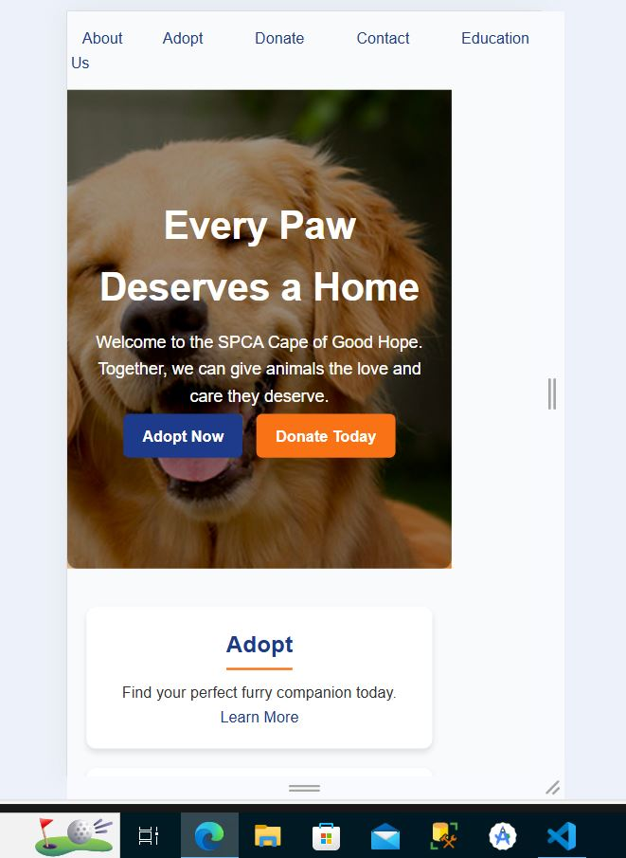

## Desktop Screenshot

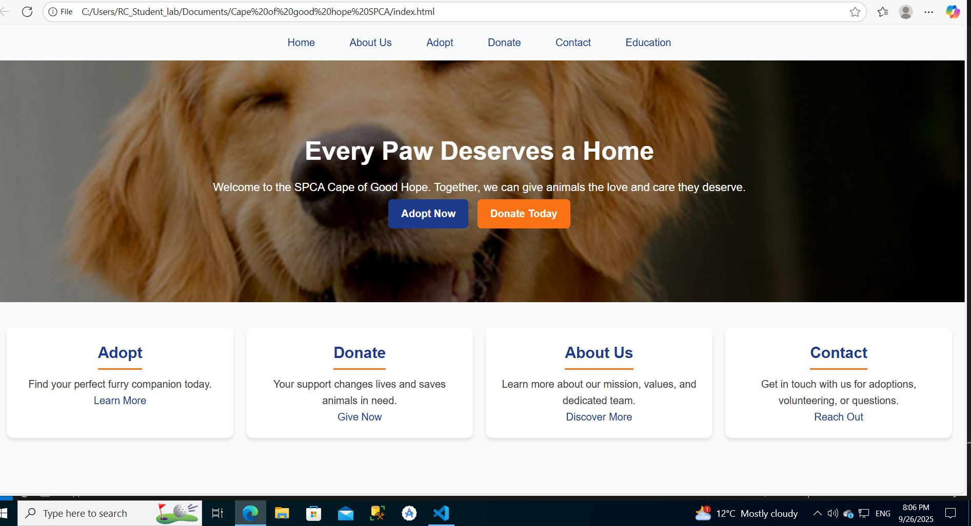

# GITHUB LINK

<https://github.com/Ayesha2150/Formative-Part-1>

REFERENCES

Mozilla Developer Network (MDN), 2023. *CSS: Cascading Style Sheets*. [online] Available at: < <https://developer.mozilla.org/en-US/docs/Web/CSS> > [Accessed 26 September 2025].

Mozilla Developer Network (MDN), 2023. *HTML: HyperText Markup Language*. [online] Available at: < <https://developer.mozilla.org/en-US/docs/Web/HTML> > [Accessed 26 September 2025].

Mozilla Developer Network (MDN), 2023. *Responsive design*. [online] Available at: <<https://developer.mozilla.org/en-US/docs/Learn/CSS/CSS_layout/Responsive_Design> > [Accessed 26 September 2025].

W3Schools, 2023. *CSS Tutorial*. [online] Available at: <<https://www.w3schools.com/css/> > [Accessed 26 September 2025].

W3Schools, 2023. *HTML Tutorial*. [online] Available at:< <https://www.w3schools.com/html/> > [Accessed 26 September 2025].

Society for the Prevention of Cruelty to Animals (SPCA), 2023. *Cape of Good Hope SPCA*. [online] Available at: < <https://capespca.co.za/> > [Accessed 26 September 2025].